**Project Name**: **File Handling**

**Developer Name: Kapil Davey**

**Project description:**

* Instantiate the BufferedWriter class.
* By passing the FileWriter object as an argument to its constructor.
* Write data to the file using the write() method.

**Algorithm** –

Step 1-Start

Step2 – Create an empty text File by if not getting create then show error message

Step 3-Write text in created file by using writestring()

Step 4-Read the same file by using File Reader class

Step 5 – Append the file

Step6 - Stop

**Flow of Project:**

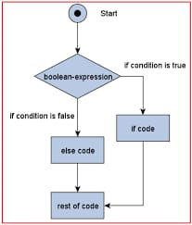

**Conclusion:**

This project is designed to add, delete and append the files using exceptions.

**GitHub Reciprocity Link**:- https://github.com/kapildavey/Phase1.git